# Performance Evaluation

Stock Data



Graphed using Highcharter. Chart type = Candlestick OHLC

Features used for building our model.

RSI: "rsiFNCL","rsiIYF","rsiXLF"

ADX: "adxFNCL","adxIYF","adxXLF"

SAR: "trendfncl","trendiyf","trendxlf"

After running PCA as part of our Feature Engineering Process, we arrived at:



Parallel analysis suggests that 2 components suffice.

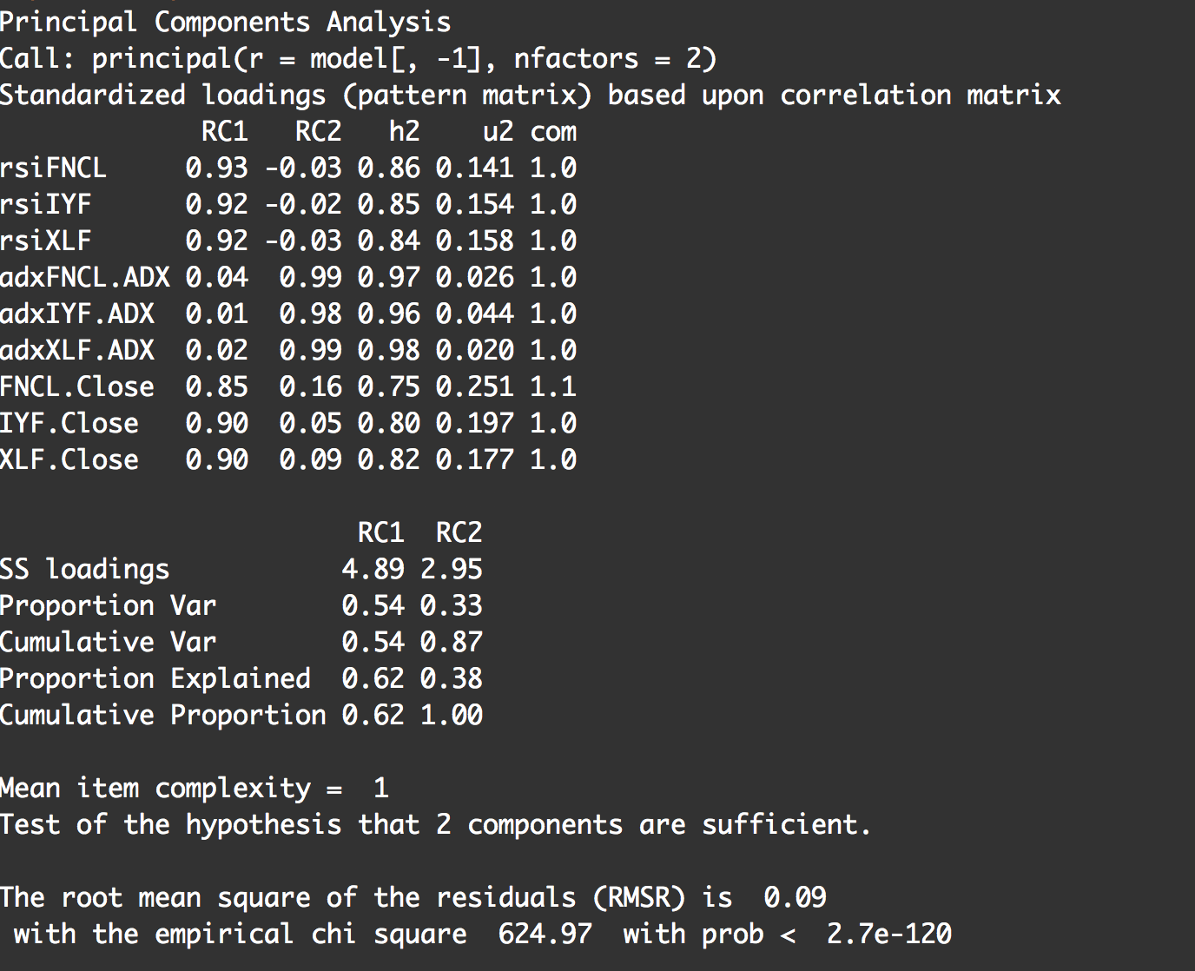

After component extraction we proceeded to run our first algorithm which was KNN classification. Using a function to automatically test for accuracy (TP+TN/Total Cases) for up to 20 N, we got a ROC curve optimized for n=8.





Our second algorithm is an approach called extreme gradient boosting which involves using gradient boosted trees (parallelized for faster computation).



We achieve an AUC Score of: 

We can achieve higher scores with xgboost by tweaking the parameters. We are currently in the process of doing so.

Here’s the current tree structure we obtained after doing so.



Extracting just the first tree:

